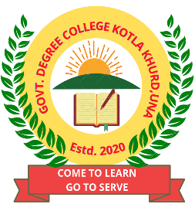

**Admission Enquiry Committee (2023-24)**

(10:00 A.M. – 5:00 P.M.)

1. **For technical queries contact**:
   1. Prof. Swaran Singh (9816615678)
2. **Help Desk Committee contact:**
   1. Ms. Raman Kumari (9805011630)
   2. Mr. Ninad Pathak ( 945977706 )
   3. Ms. Davinder Rihal (884186744)
   4. Ms. Monika Rana ( 8580804511)
3. **For admission queries (B.A.) contact:**
   1. Prof. Sunny Sharma ( 9805377102 )
   2. Prof. Onkar Singh ( 9816838297 )
   3. Ms. Mamta Kumari (9418214668)
4. **For admission queries (B.Com.) contact:**
   1. Prof. Devinder Atlas ( 9418096315 )
   2. Ms. Neena Kumari ( 8580929946 )
   3. Ms. Kanika Sharma (7018899157)
5. **For admission queries (BBA) contact:**
   1. Ms. Shweta Dhiman (8629068727)
6. **For admission queries (BCA./PGDCA) contact:**
   1. Ms. Davinder Rihal (884186744)
   2. Ms. Varsha Ranii ( 9015453986)